**PART 1**

Question A:

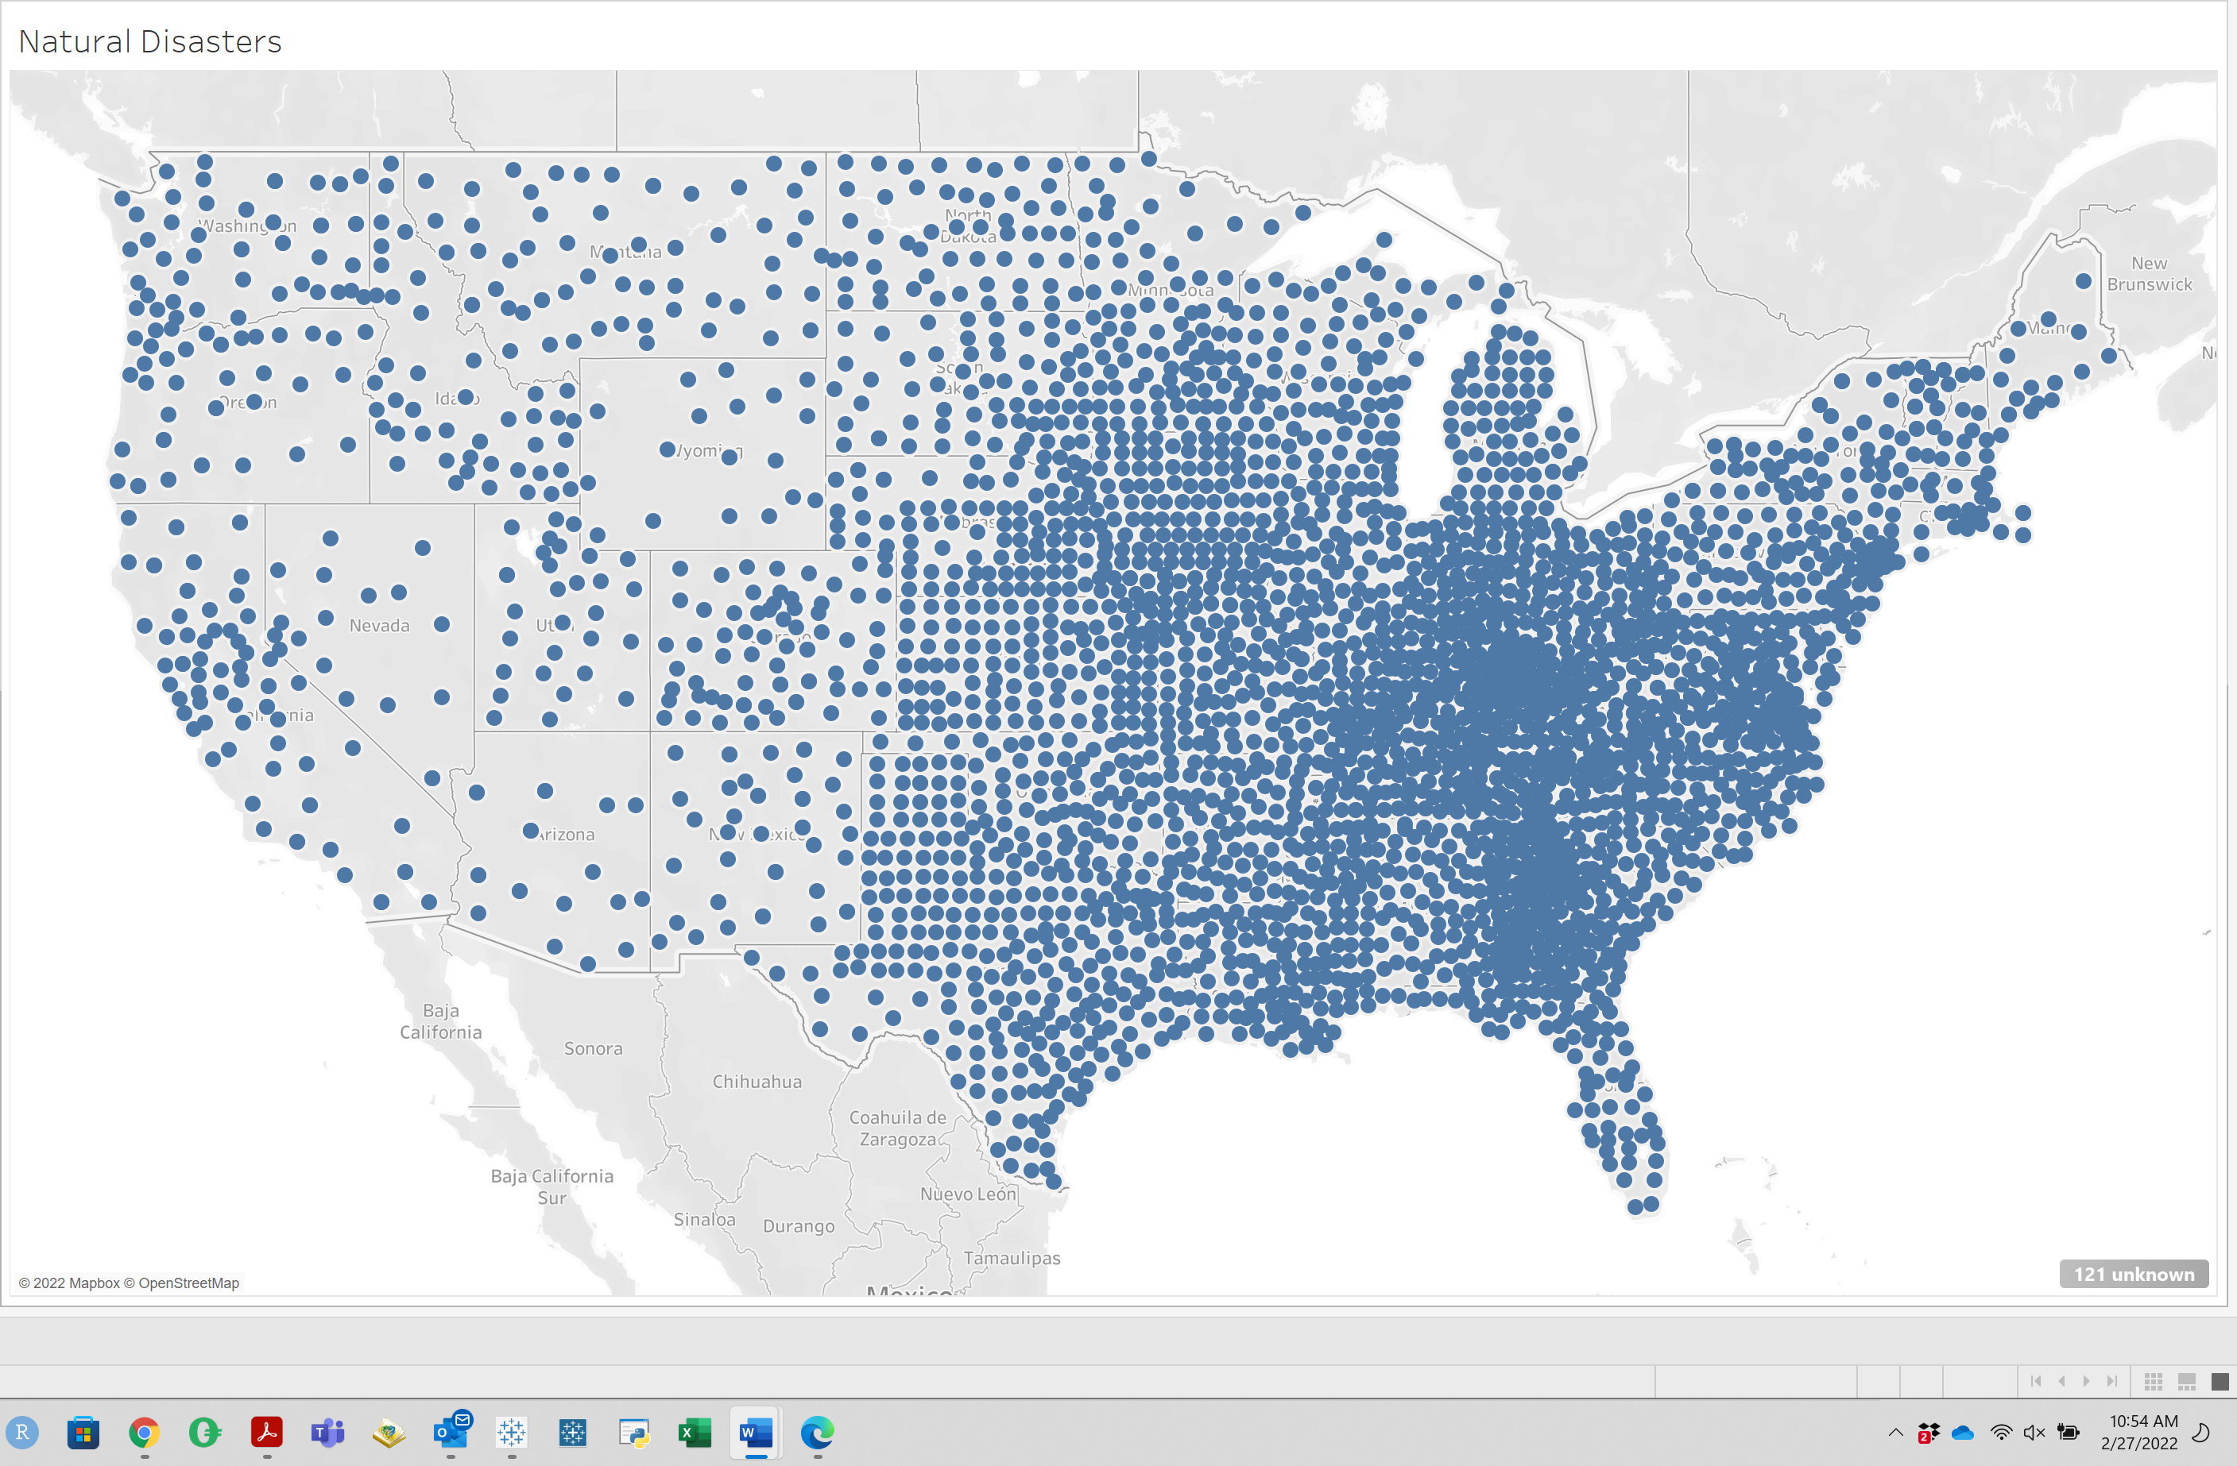

Question B:

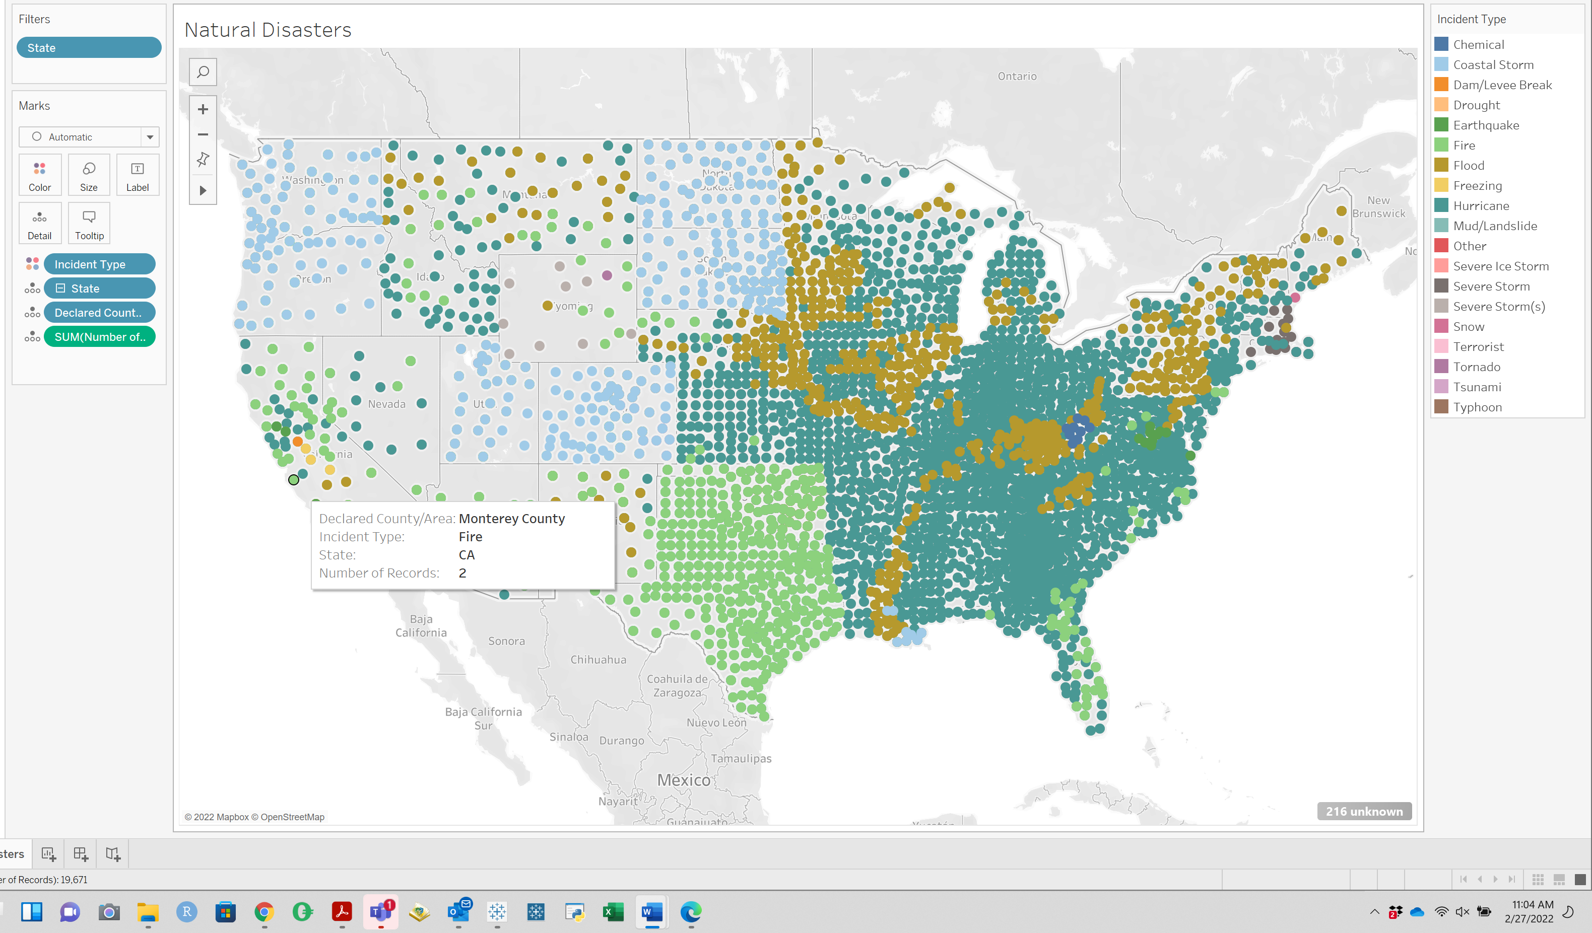

Question C:

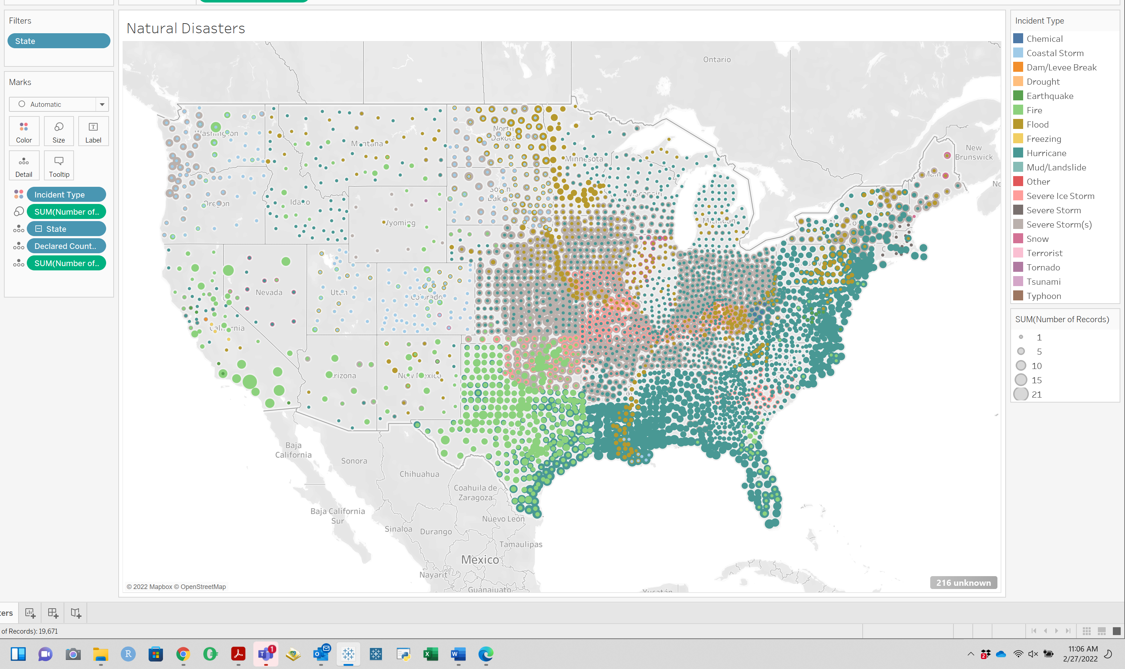

Question D:

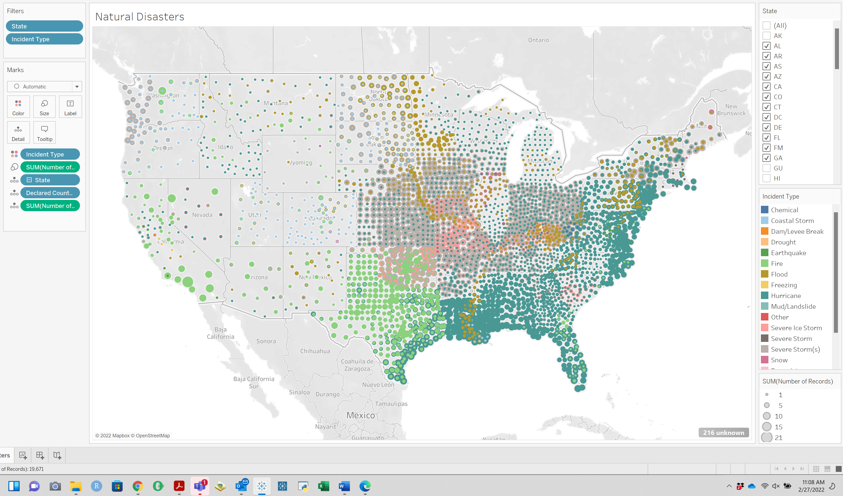

Question E: Alabama is almost exclusively huricanes. Texas is mostly fires away from the coastline but hevily influenced by huricanes along its coast.

Question F: Alaska and Hawaii are not on the map because we removed them through the filter.

Question G: We have encoded the different disasters through **c. Using Color**

Question H: We have visually encoded the number of Disaster incidents in a county through **b. Size**

**PART 2:**

Question I:

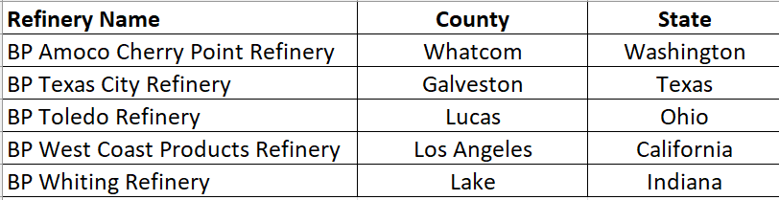

Question J:

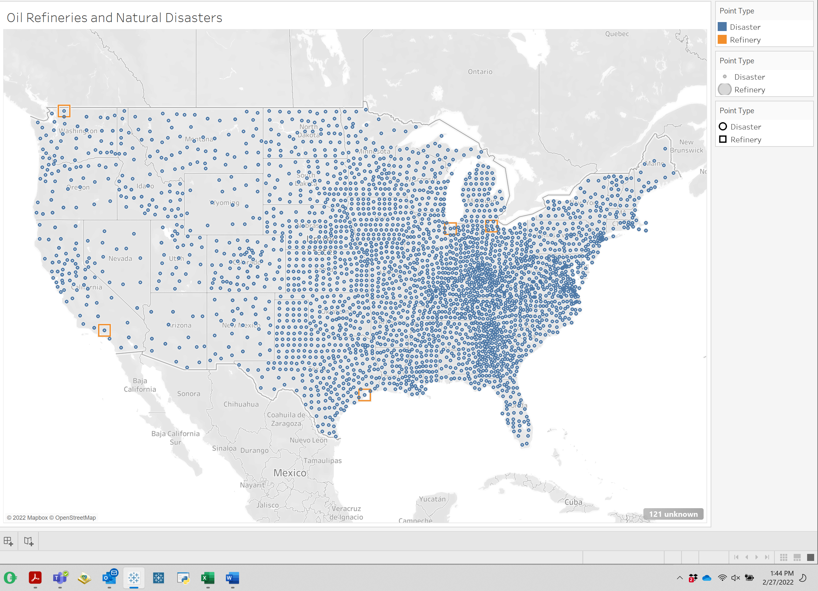

Question K:

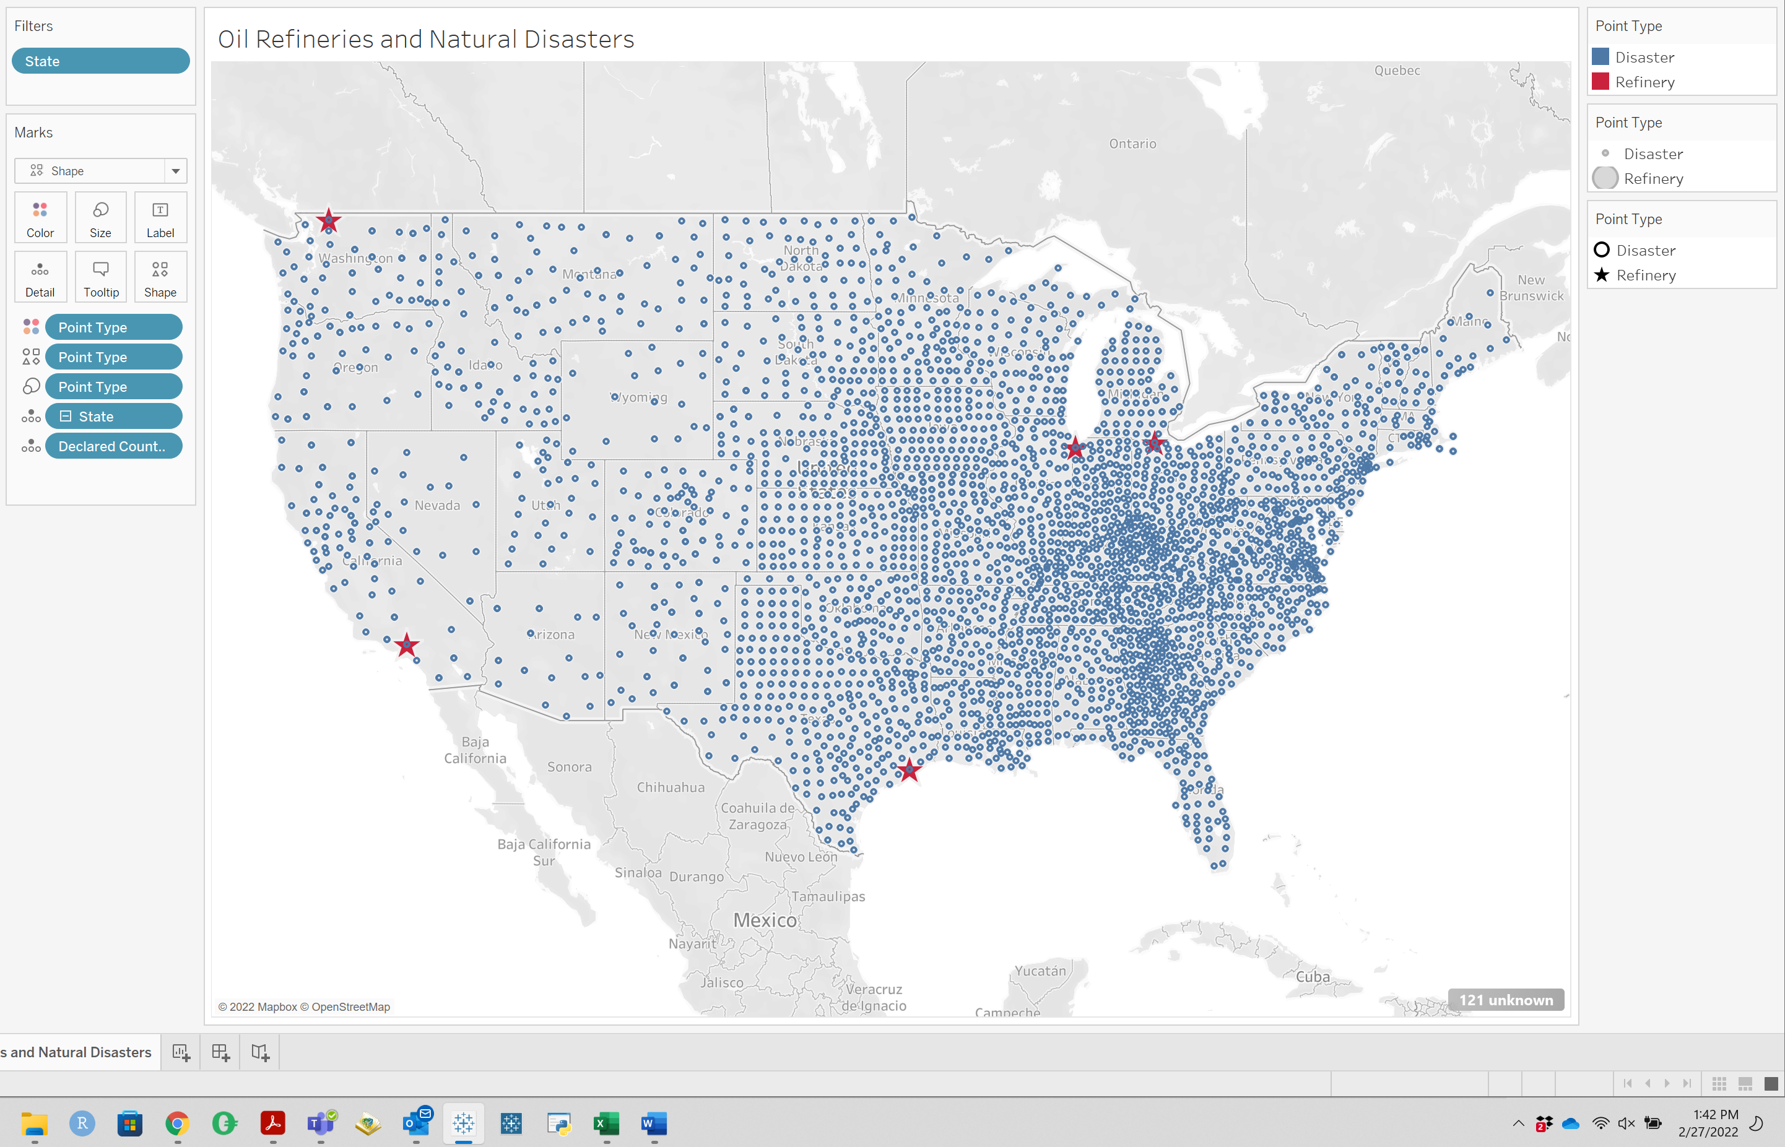

Question L:

BP has efineries in California, Washington, Texas, Indiana and Ohio.

**PART 3:**

Question M:

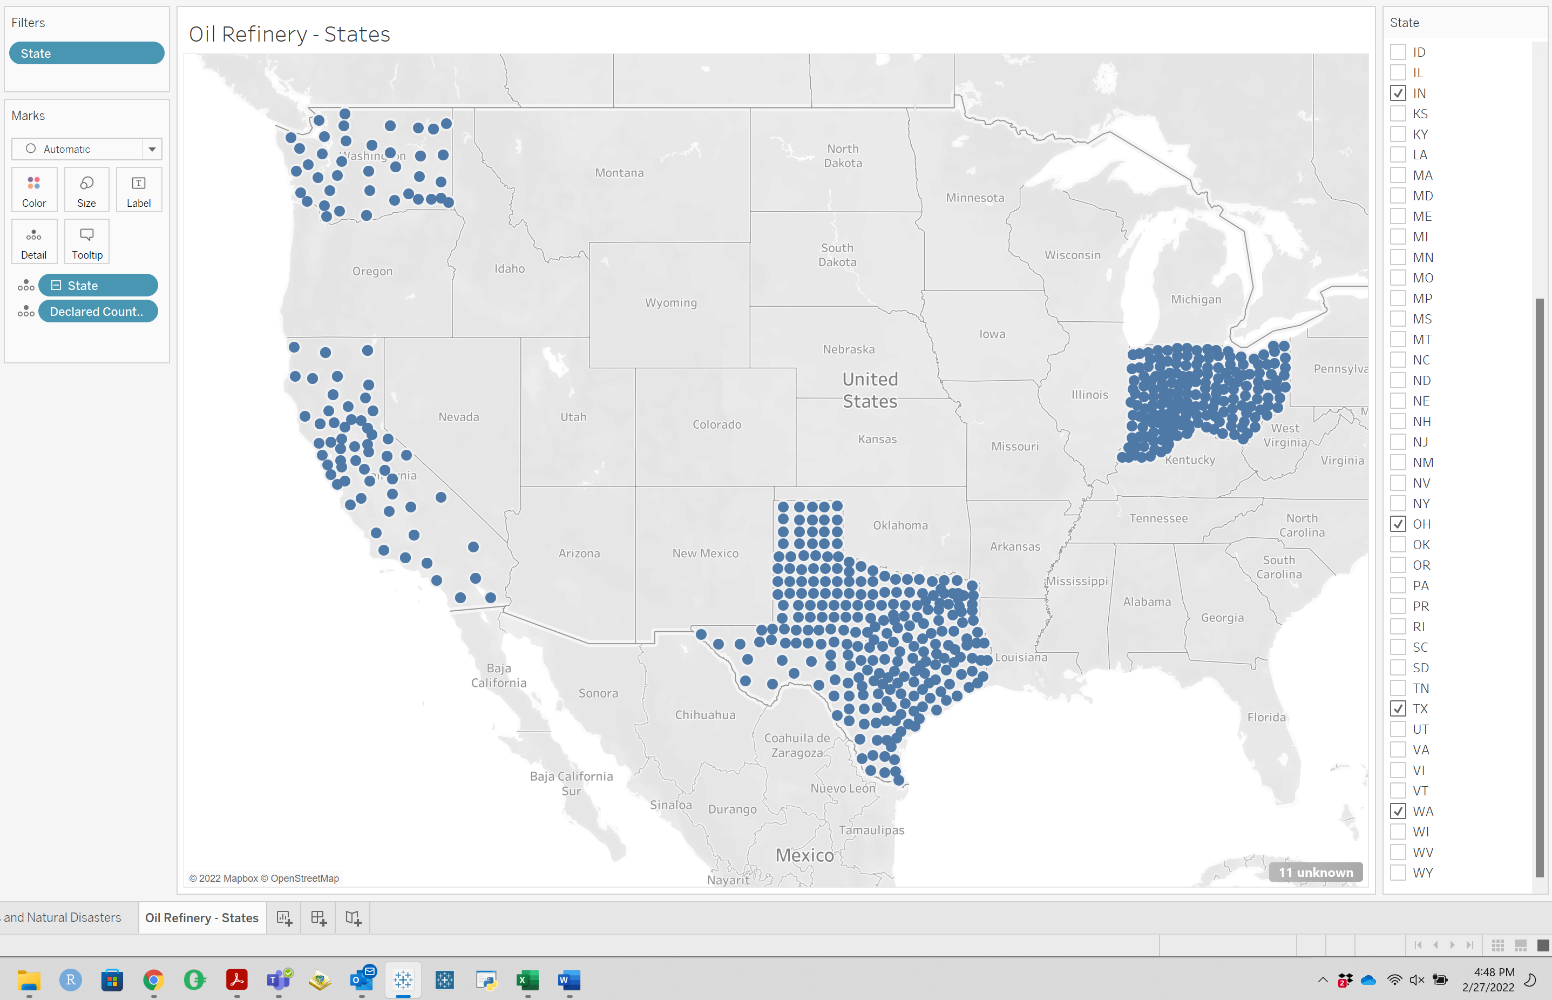

Question N:

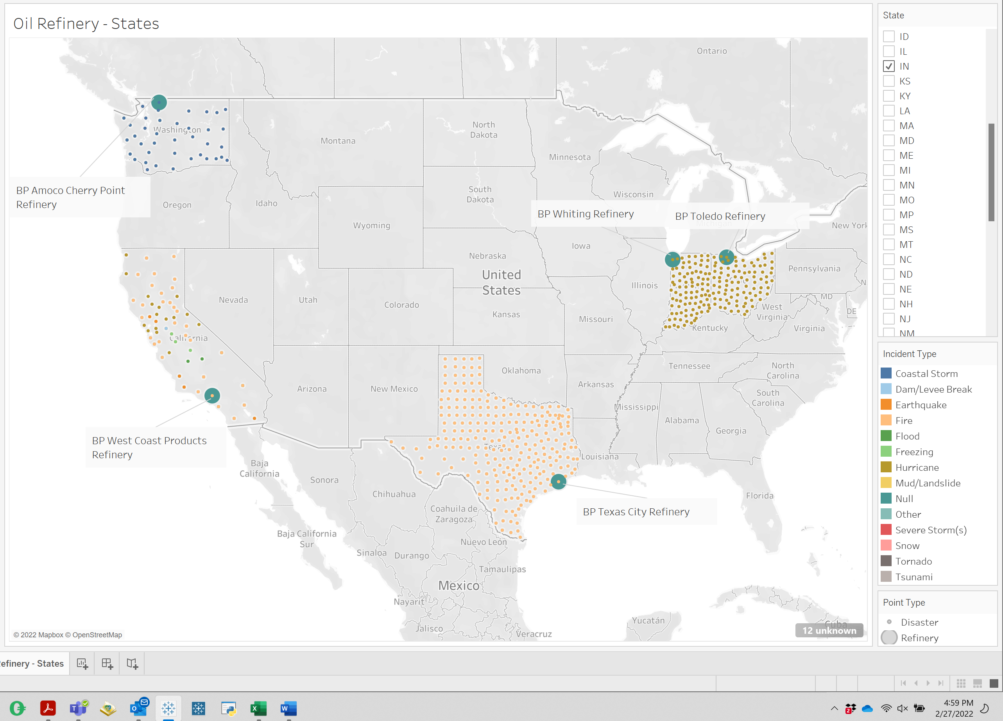

Question O:

Washington: Coastal Storm, Fire, Flood, Mud/Landslide, Severe Storm

Ohio: Hurricane, Severe Storm, Snow

**Part 4:**

Question P:

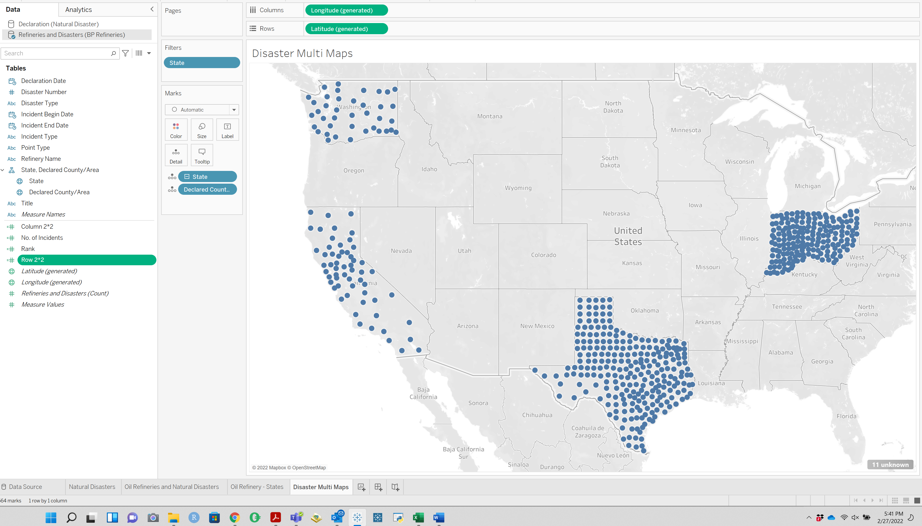

Question Q:

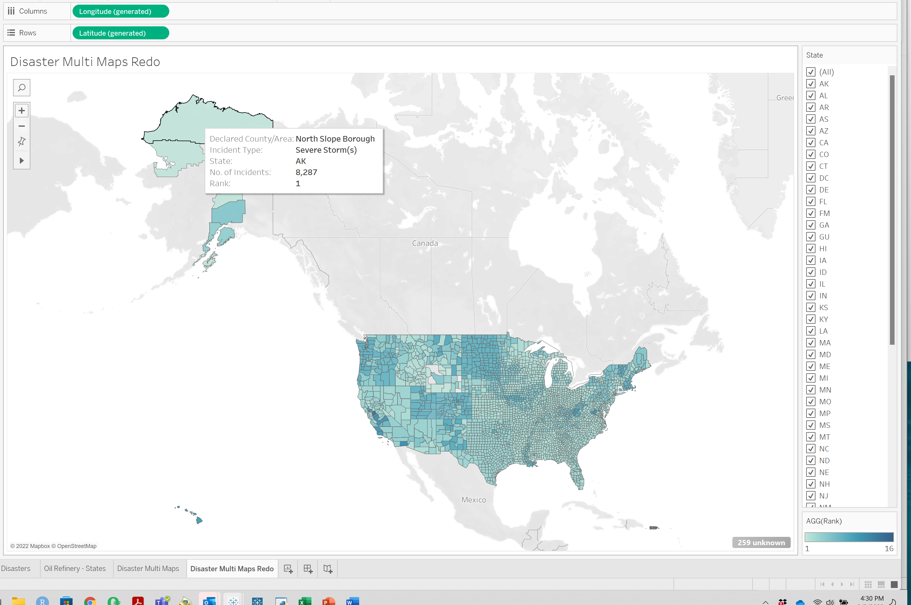

The top ranked disaster when looking at all states is Severe Storm

Question R

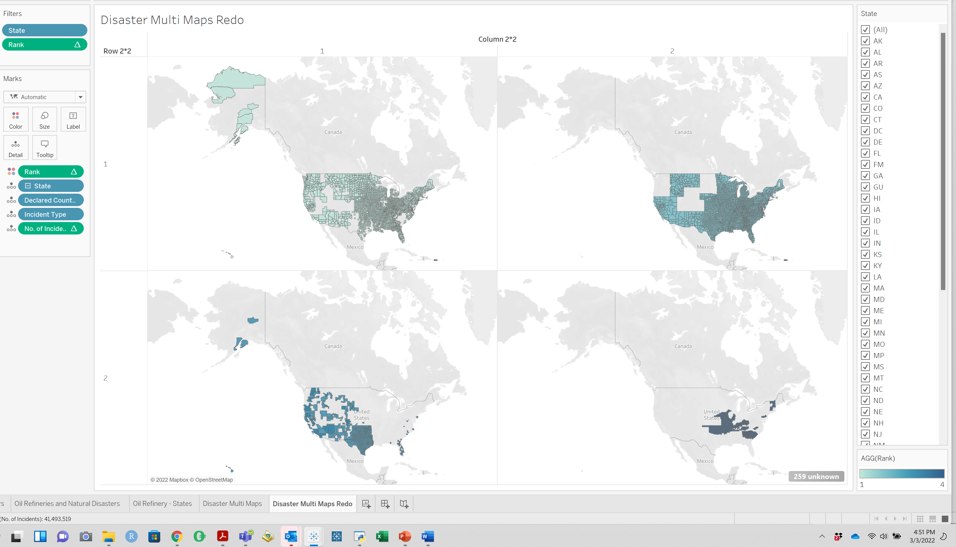

Question S:

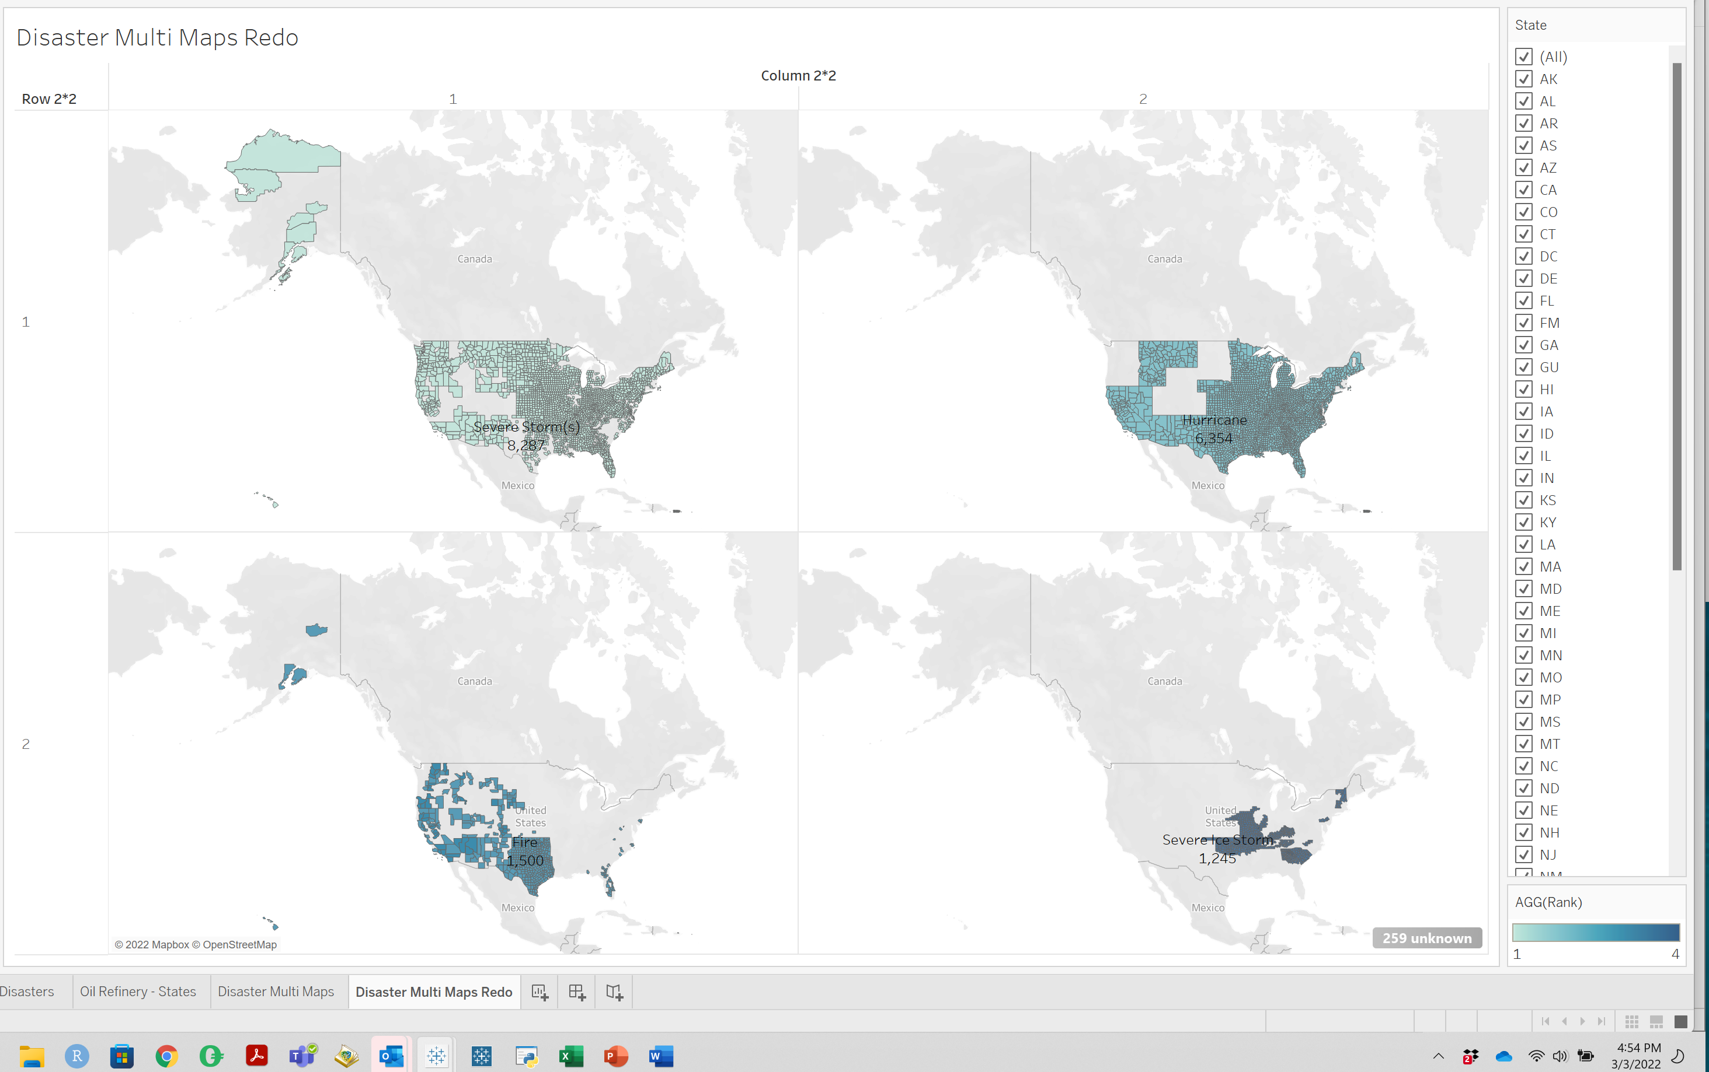

Question T:

The calculated fields were all added to the measure pane and not the dimension pane because all of them generated values.

**Part 5:**

Question U:

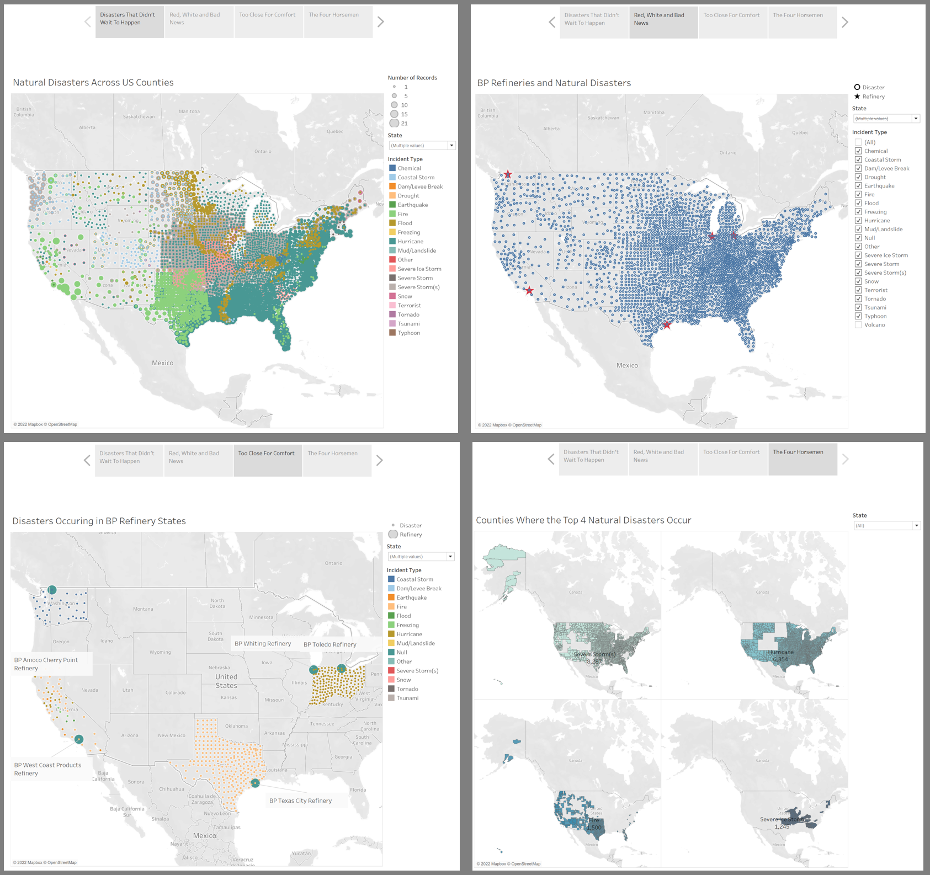

Question V:

The Rhetoric I picked to fit the visualization was Emotion. The captions are play on words that denote a cause for concern. I wanted to stress to the audience that natural disasters are very real threats to the operations of BP refineries here in the United States.

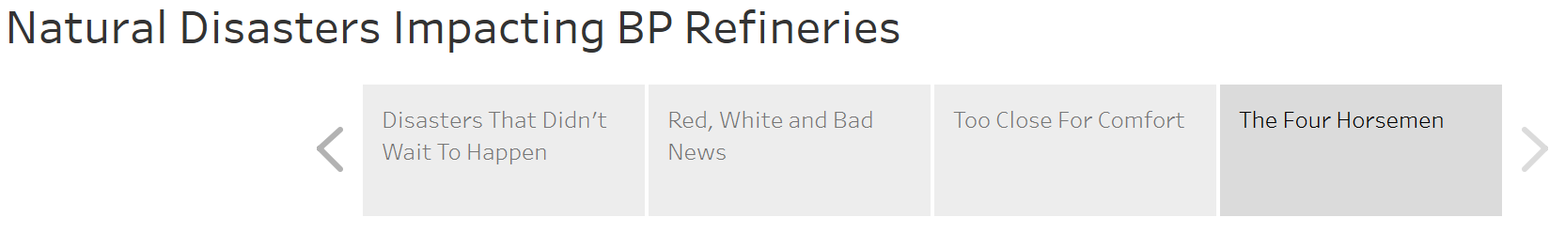

**Submission Note**:

I left my original interpretation of the the Disaster Multi Map in the Tableau file. To me, that would make more sense because it embodies the rankings of the natural disasters that exist in the states in which BP operates. It also reduces visual noise for the audience. However, for the purpose of the Story, I used the “Disaster Multi Maps Redo” Sheet which includes all of the states.

I did not include the Incident Type Filter for the final story page as it would not make sense to allow filtering on this page at the incident level.